

Report

On

**Paper Presentation Competition**

To Mark

**World Ozone Day 2023**

**Date:** 19th September 2023, **Venue:** D113, **Time:** 2:30 pm

The World Ozone Day is observed annually on September 16. The day is marked to create awareness about the importance of the conservation of the ozone layer which is depleting rapidly leading to global warming and climate change. The day is also recognized to commemorate the Montreal Protocol which was adopted in the year 1987. In fact the **sustainable Development Goals 13 and 15** adopted by the United Nations also accentuate climate action and protection of life on land. To create awareness and encourage a sense of responsibility towards the conservation of the environment among the students, the **Department of Chemistry** in collaboration with the **Department of Environmental Science** organized a paper presentation competition to mark World Ozone Day. The event was organized on 19th September 2023 at 2:30 pm onwards in D-113. An educational video on this year’s theme **“Montreal Protocol: Fixing the Ozone Layer and Reducing Climate Change”** was shown to the audience and later on, the hazardous consequences of ozone depletion were explained by Dr. Mohd. Imran Ahmad from the Department of Chemistry. The participants from different streams presented their views through attractive and informative presentations. The activity was coordinated by **Dr. Tahmeena Khan**, Assistant Professor, Department of Chemistry, **Dr. Mohammad Imran Ahmad**, Assistant Professor, Department of Chemistry and **Dr. Amina Jafri**, Assistant Professor, Department of Environmental Science. The competition was judged by **Dr. Rahila Rahman Khan**, Assistant Professor, Department of Environmental Science and **Dr. Shahla Tanveer**, Assistant Professor, Department of Chemistry. **Mohd. Arsh Khan** and **Hera Shakeel** were the student coordinators for the event. The winners of the competition were:

Ist Position- Mr. Kabir Singh (M.Sc. EVS 1st Year)

IInd Position- Ms. Arshi Fatima (M.Sc. EVS 2nd Year)

IIIrd Position- Ms. Ayushi Singh (B.Sc. Biotechnology 1st year)

Ms. Aaliya Salam (BCA 1st Year)

Ms. Fru Mark (B.Tech. CSE)

The event was attended by around 85 people including the faculty members from the collaborating departments.

**GLIMPSE OF THE EVENT**

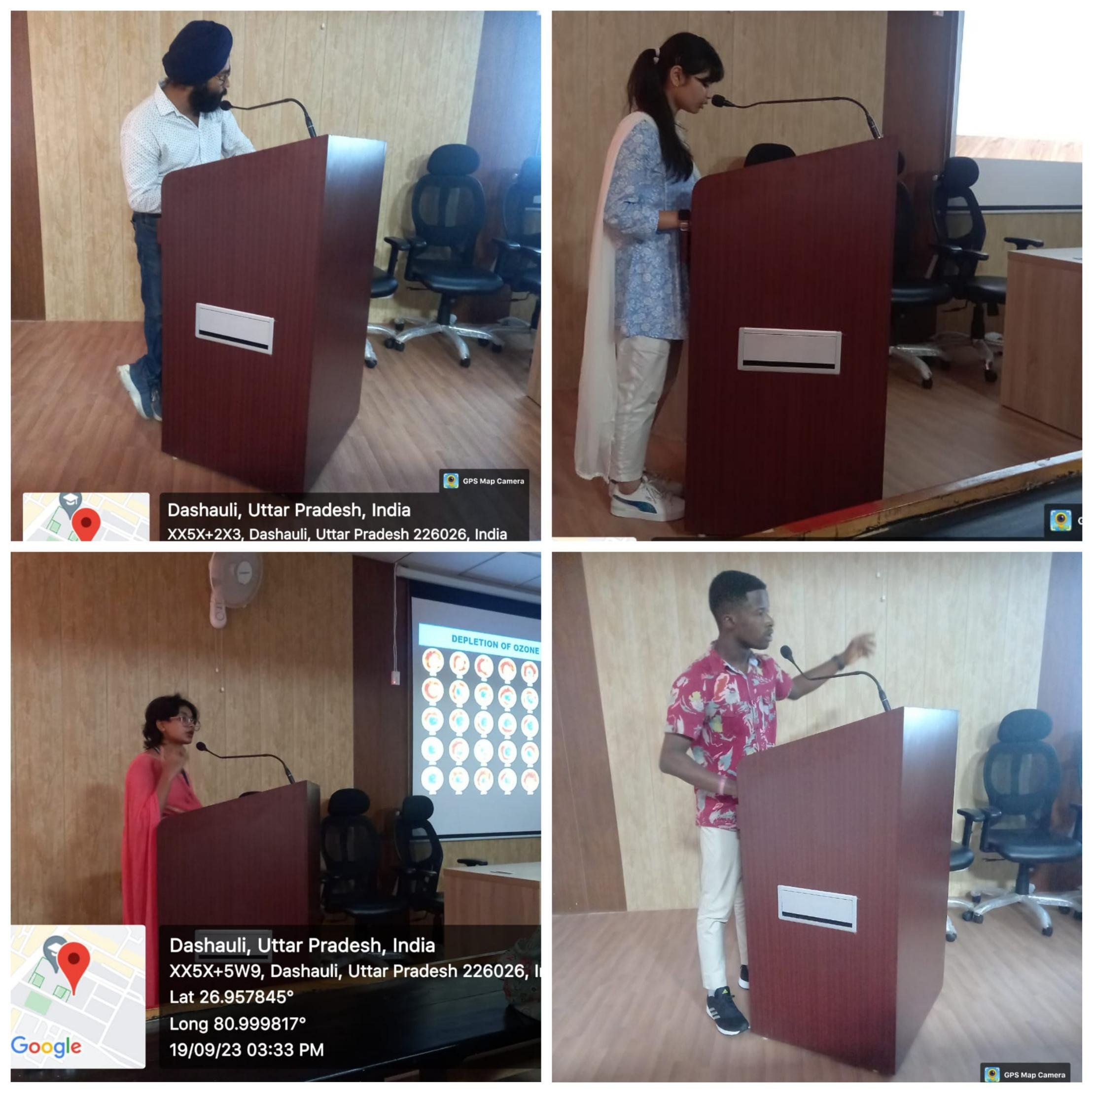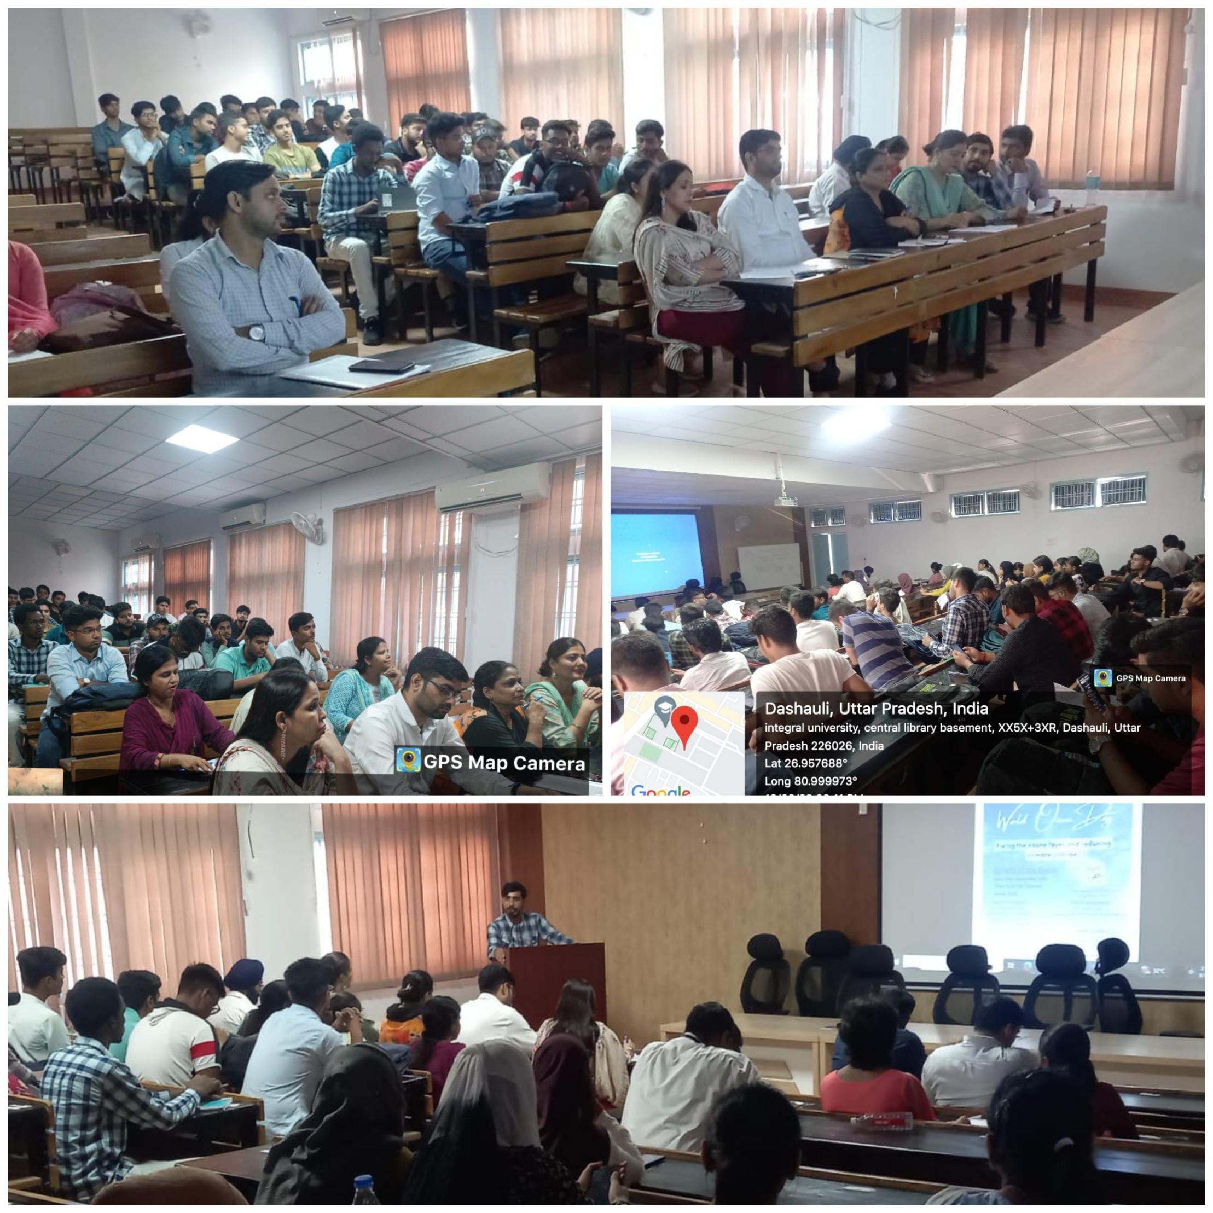

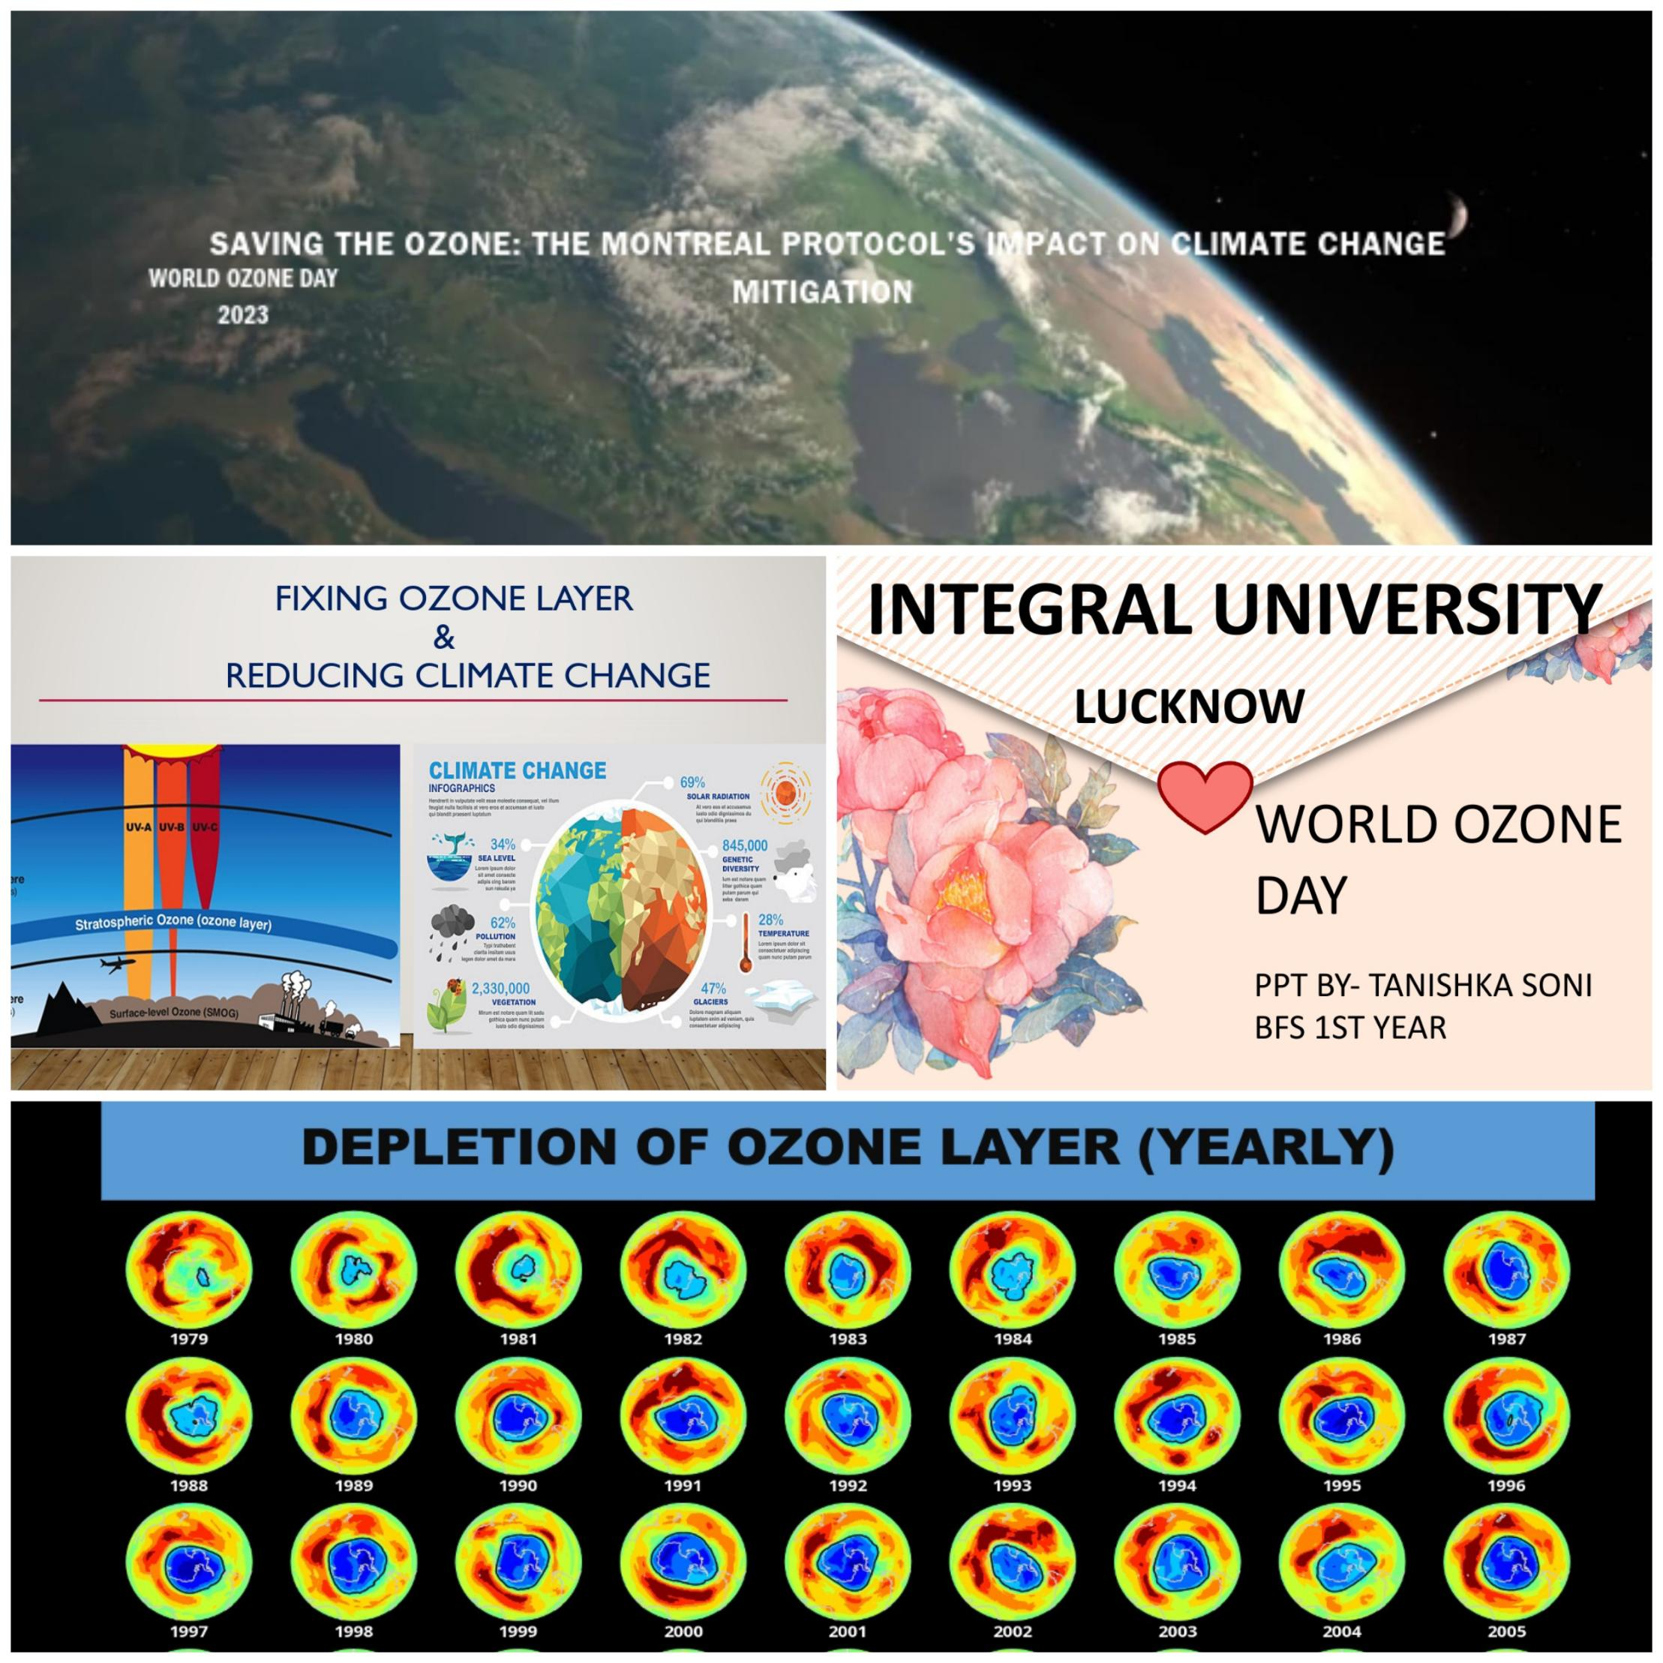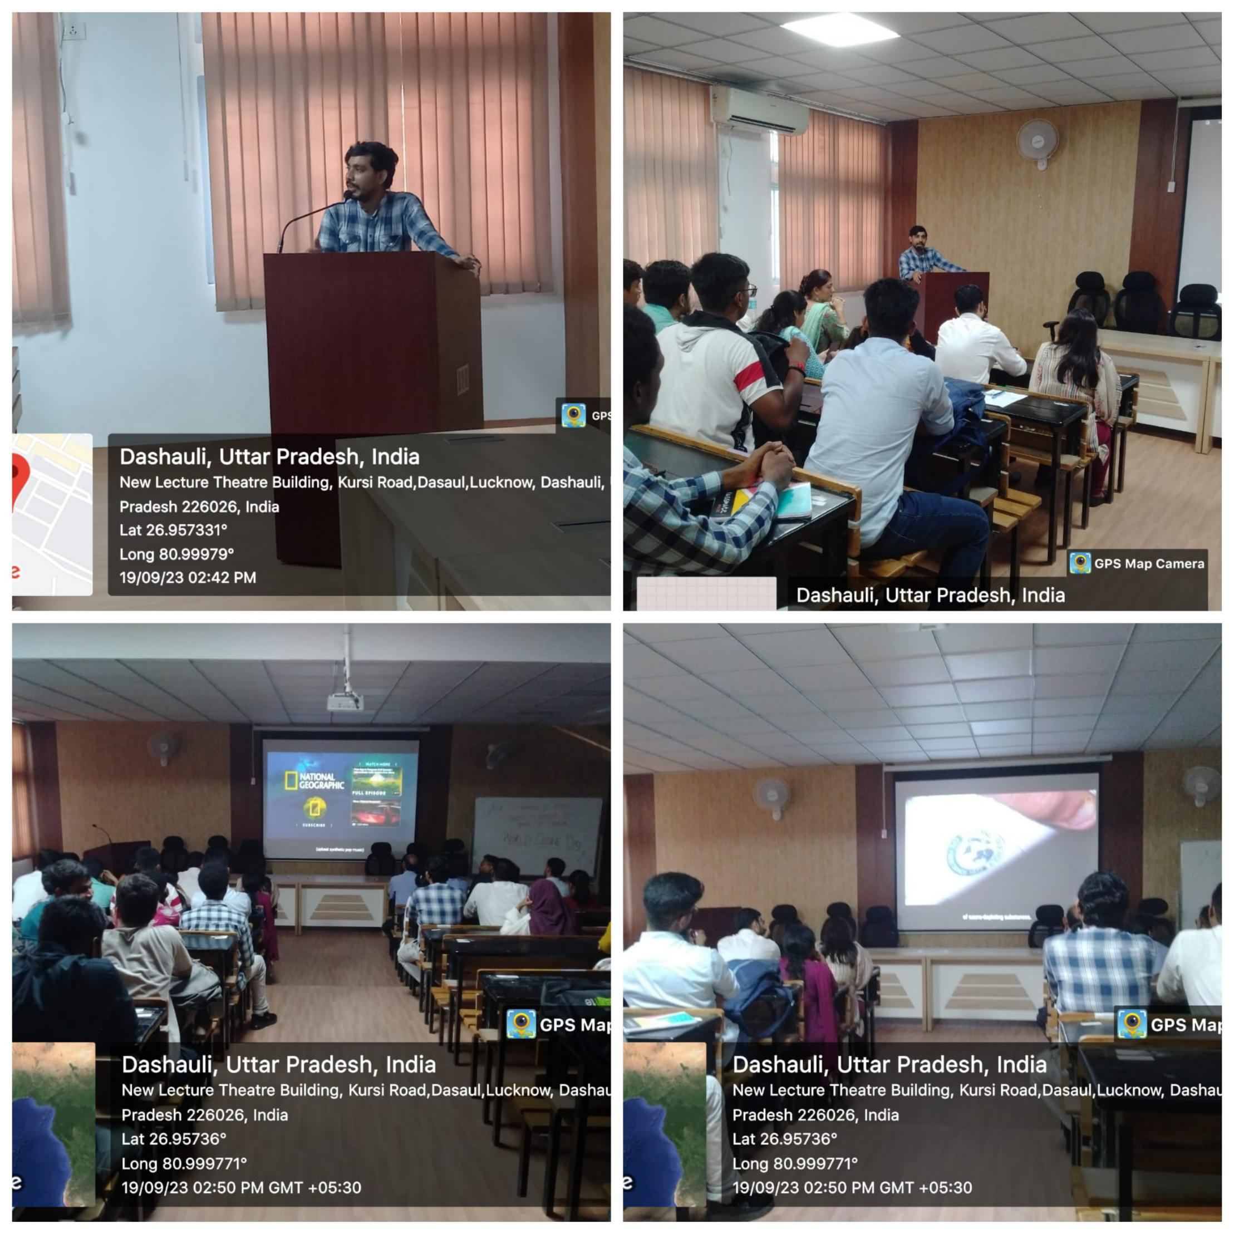

Respectfully Submitted by:

***Dr. Tahmeena Khan***

*Assistant Professor*

*Integral University, Lucknow*